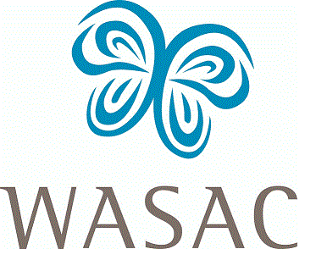

Wichita Area Sexual Assault Center works with individuals and communities through comprehensive services and education to create a culture of intolerance for sexual violence and an atmosphere of healing for those impacted by it.

WICHITA AREA SEXUAL ASSAULT CENTER (WASAC) OUTREACH VOLUNTEER APPLICATION

Applicant name
Last | First | MI
Please list all other names previously used
Last | First | MI
Last | First | MI
Last | First | MI

Contact information
Preferred phone number(s)
Email address

Home address | Number of years at current address:
Street | City, State | ZIP
Mailing address, if different than above
Street | City, State | ZIP
Previous address
Street | City, State | ZIP

Employment and school information
Employer name | Position held
Previous employer, if less than 1 year with above | Position held
Are you currently a student? Y N
College attending/attended | Degree, if any | Year
Are you willing to make a minimum of a one year commitment to WASAC? Y N

Please list any special education or training that would help you as a WASAC volunteer.
Please list community or board affiliation(s).
How did you learn about WASAC?
Have you ever been convicted of a crime? Y N

Emergency contact information
Name | Phone | Relationship to you

References – please list two professional and one character reference (other than family members)
Name |  | Relationship | Years known | Phone
Name |  | Relationship | Years known | Phone
Name |  | Relationship | Years known | Phone

I UNDERSTAND I MUST COMPLETE AGENCY TRAINING BEFORE VOLUNTEERING.

I HEREBY CERTIFY THAT THE INFORMATION I HAVE GIVEN IS TRUE AND CORRECT TO THE BEST OF MY KNOWLEDGE.

I GIVE MY CONSENT TO THE WICHITA AREA SEXUAL ASSAULT CENTER TO VERIFY THE INFORMATION GIVEN, INCLUDING A BACKGROUND CHECK AS WELL AS CONTACTING LISTED REFERENCES.

Signature | Date

Updated 2018

